Тема: At the zoo

Цели урока:

1. Образовательная:
- Формировать лексические навыки учащихся по теме “At the zoo”;
Сопутствующие задачи:
- Совершенствовать навыки говорения;

2. Развивающая:
- развивать умение диалогической речи учащихся;

3. Воспитательная:
- Сопутствовать воспитанию общительности и коммуникативности;

Оборудование:
- Л. М. Лапицкая, Н. В. Демченко, А. И. Калишевич, Т. Ю. Севрюкова «Английский язык для 3 класса». Минск: «Вышэйшая школа», 2018;
- дидактический материал;
- презентация;

Литература:
- Л. М. Лапицкая, Н. В. Демченко, А. И. Калишевич, Т. Ю. Севрюкова «Английский язык для 3 класса». Минск: «Вышэйшая школа», 2018;

Ход урока

№ п/п | Этап урока | Задача этапа | Содержание этапа | Учащиеся | Время
1. | Организационный момент | Подготовить учеников к работе. Введение в языковую среду, создание благоприятной атмосферы, постановка цели урока, сообщение темы и плана урока. | Hello, pupils. How are you today? What day is it today? What’s the weather like today?  Look at the screen. What can you see at this picture? Where can you see these animals? (at the circus, at the zoo) Right! Today we will talk about animals, which we can see at the zoo.  Now look at the blackboard, let’s see what we’ll do today at the lesson. | Pupils answer the questions | 4 min
2.  2.1  2.2  2.3  2.4 | Основной этап  Проверка домашнего задания  Введение нового лексическогоматериала  Работа с текстом  Физ. пауза 2  Послетекстовое задание  Совершенствование навыков диалогической речи | Организовать проверку домашнего задания учащихся.  Тренировка лексических навыков  Организация релаксации  Тренировка лексических навыков  Формирование навыков диалогической речи | Firstly, let’s check your home task.  Your hometask was ex. 5, p. 117. You were to right about animals: what they can and can’t do. Answer my questions, please. What can bears do? What can’t bears do? What can monkeys/ lions/ tigers do? What they can’t do?  Let’s continue!  Look at the screen, please. Today we will go to the zoo! We can see a giraffe. What colour is giraffe? Is it big or little? Hippo/elephant/fox/crocodile.  Game “DOMINOES” (Приложение 1)  A “paper-ball” game. A crocodile-crocodiles, a hippo-hippos, a fox-foxes.  Now, open please your books at page 118, ex. 2a. Look at the picture, what animals can you see at the zoo? You can see 3 animals but 4 paragraphs. Which animal is missing? Read and match.  Video “Head, shoulders, knees and toes”  And now take please your telephones and cards with qr-codes. (Приложение 2) Open “viber”, and scan your qr-codes. Work in pairs. Raise your hand, if you have any problem.  Now look at the screen please. This is a dialogue. Let’s read it.  Mike: Hello, Liz.  Liz: Hello, Mike.  Mike: How are you?  Liz: I’m great! And you?  Mike: I’m OK. Let’s go to the zoo.  Liz: Oh, that’s a good idea.  At the zoo  Liz: What’s your favourite animal?  Mike: I like elephants. They are big and grey. They’ve got big ears and long nose. They can run, swim and dance. They eat leaves, grass, bananas and drink water.  And what’s your favourite animal?  Liz: I like hippos. They are big and funny. They can swim very well. They eat grass and drink water.  Good job! And now your task is to make up your own dialogues. I’ll give you cards with dialogues. Firstly you should fill in the gaps and then act the dialogue out. (Приложение 3) | Pupils answer the questions.  Pupils learn new words  Pupils play the game  Pupils listen and read the text  Pupils read the text.  Pupils do the task  Pupils read the dialogue  Pupils do the task and act out the dialogues | 4-5 min  4  min  5 min  2 min  5 min  2  min  5 min  4 min  10 min
3. | Подведение итогов урока. Рефлексия | Анализ и оценка успешности достижения цели | Now I’ll give you tables. | Pupils answer the questions | 1 min
4. | Информирование учащихся о домашнем задании |  | Your home task will be to do the crossword. (Приложение 4) | Write down home task. | 1 min

START | I HAVE GOT | I HAVE GOT | I HAVE GOT
 |  | 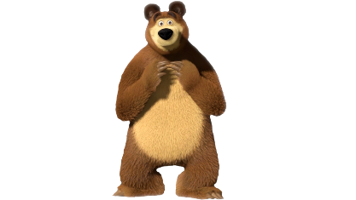 | 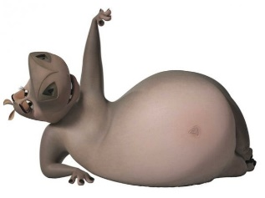
WHO HAS GOT | WHO HAS GOT | WHO HAS GOT | WHO HAS GOT
 |  |  | 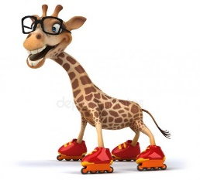
I HAVE GOT | I HAVE GOT | I HAVE GOT | I HAVE GOT
 | 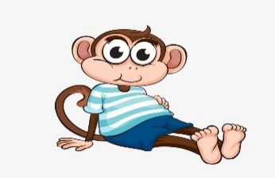 | 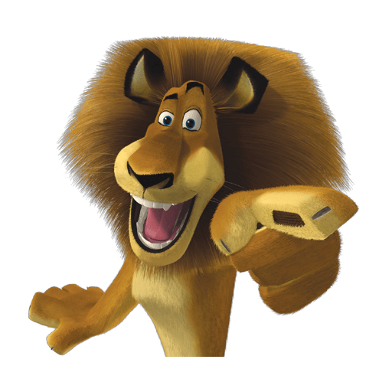
WHO HAS GOT | WHO HAS GOT | WHO HAS GOT | WHO HAS GOT
 |  |  | 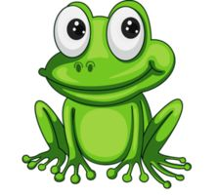
I HAVE GOT | I HAVE GOT | I HAVE GOT | I HAVE GOT
 | 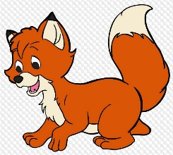 |  | 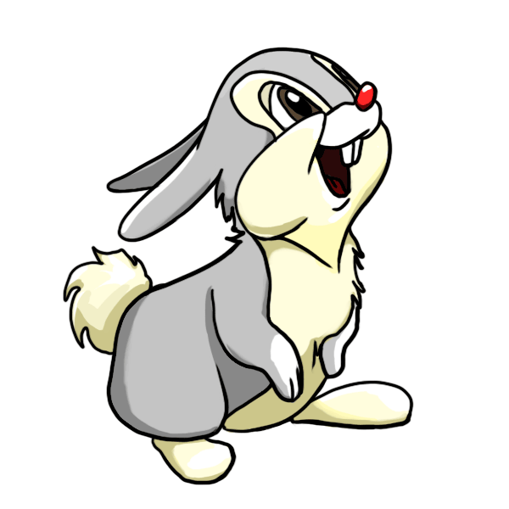
WHO HAS GOT | WHO HAS GOT | WHO HAS GOT | WHO HAS GOT
 |  |  | 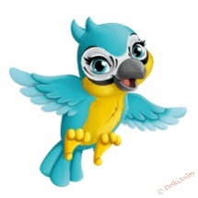

Приложение 1

I HAVE GOT | I HAVE GOT | I HAVE GOT | I HAVE GOT
WHO HAS GOT | WHO HAS GOT | WHO HAS GOT | WHO HAS GOT
 |  |  | 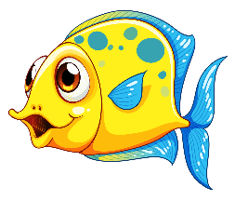
I HAVE GOT | I HAVE GOT | I HAVE GOT | I HAVE GOT
 | 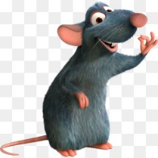 | 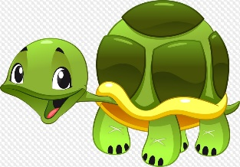 | 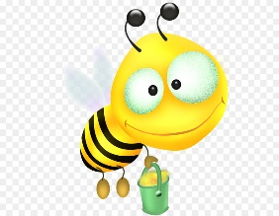
WHO HAS GOT | WHO HAS GOT | WHO HAS GOT | WHO HAS GOT
I HAVE GOT | I HAVE GOT | I HAVE GOT | I HAVE GOT
 | 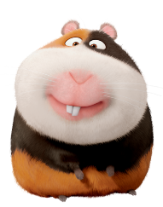 | 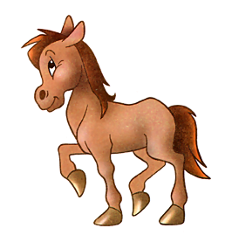
WHO HAS GOT | WHO HAS GOT | WHO HAS GOT | END

Приложение 2

Приложение 3

P1: Hello, .
P2: Hello, .
P1: How are you?
P2: I’m great! And you?
P1: I’m OK. Let’s go to the zoo.
P2: Oh, that’s a good idea.
At the zoo
P2: What’s your favourite animal?
P1: I like . They are and . They’ve got ears and nose. They can and . They eat and drink .
And what’s your favourite animal?
P2: I like . They are and . They can and . They eat and drink _____ .

P1: Hello, .
P2: Hello, .
P1: How are you?
P2: I’m great! And you?
P1: I’m OK. Let’s go to the zoo.
P2: Oh, that’s a good idea.
At the zoo
P2: What’s your favourite animal?
P1: I like . They are and . They’ve got ears and eyes. They can and . They eat and drink .
And what’s your favourite animal?
P2: I like . They are and . They can . They eat and drink _____ .

Help box:
Brown, run, climb trees, honey(мёд), water, little(2), big.
Big, grey, swim, grass, water.

P1: Hello, .
P2: Hello, .
P1: How are you?
P2: I’m great! And you?
P1: I’m OK. Let’s go to the zoo.
P2: Oh, that’s a good idea.
At the zoo
P2: What’s your favourite animal?
P1: I like . They are and . They’ve got ears and nose. They can and . They eat and drink .
And what’s your favourite animal?
P2: I like . They are and . They can and . They eat and drink _____ .

Help box:
Grey, run, big(2), bananas, long, leaves, swim.
Little, brown, bananas, climb trees, water, jump.

Приложение 4

